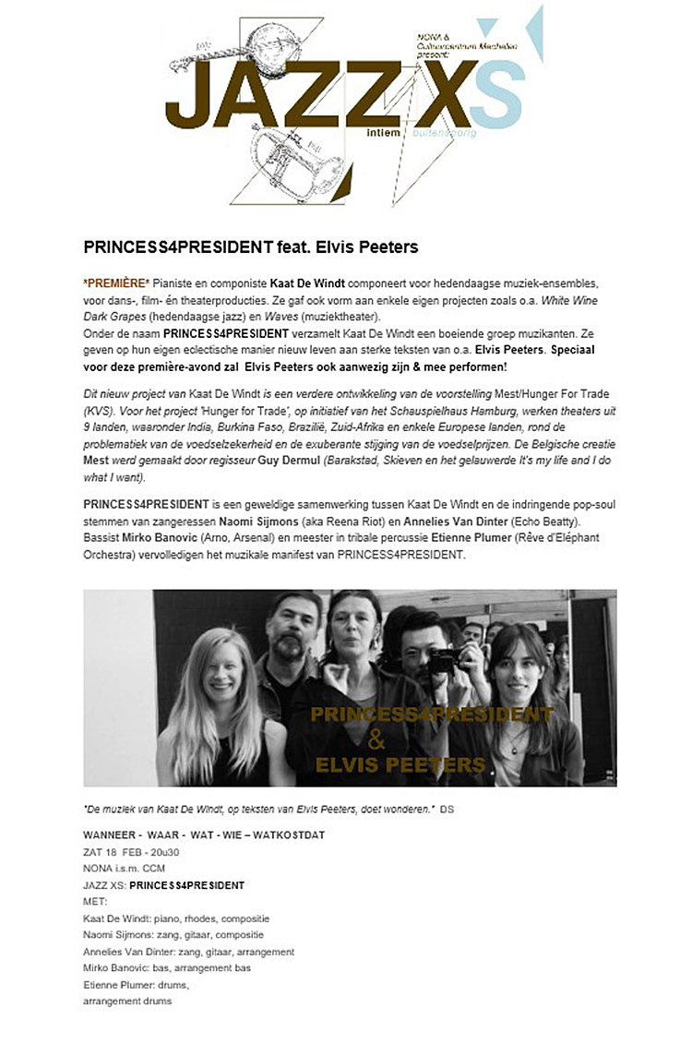

http://www.jazzepoes.be/2017/archiefmusic2017-JANFEB.html

